“COMPACT” CRANE RADIO SYSTEM

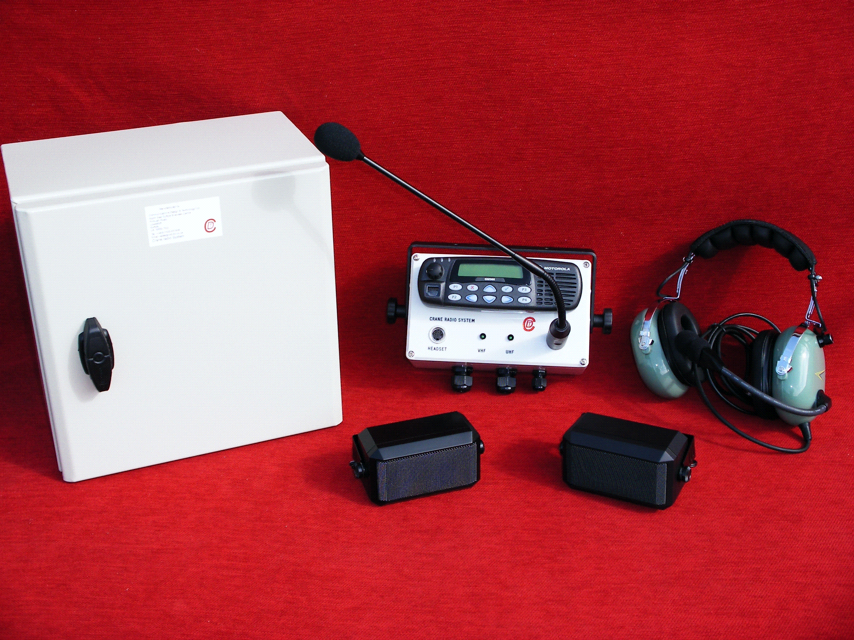

To meet the need for a more compact safe area crane radio system a unit has been designed and manufactured that can be installed in the smallest cab.

The new compact unit uses Motorola radios with a standard single remote control head.

Using licensed Motorola software an interface has been developed to allow ALL functions to be initiated from this control head. Switching from VHF to UHF, the display on the control head indicating to which radio it is connected. Both radios continue to be monitored irrespective of which radio is selected, by means of each radio having its own dedicated speaker. In addition, the optional PA is enabled from this control head again indicating that the PA has been selected on the display. No external switch boxes are needed.

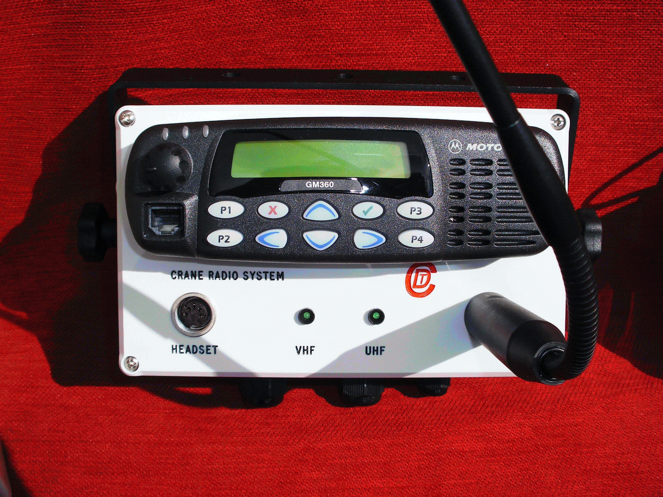

The main equipment is mounted in an IP66 enclosure.

The system is supplied with, footswitch or push button, for radio PTT / PA operation, gooseneck microphone. Headset option available.

Although supplied with Motorola GM360 radios the system can be adapted to accommodate other Motorola professional models.

Other configurations are available to suit customer’s requirements.

Technical Specifications



RADIOS VHF UHF
Frequency Range 136MHz-174MHz 403MHz-470MHz
Channel Spacing 12.5/20/25kHz 12.5/20/25kHz
Transmit Power 1-25 watts 1-25 watts
Receive Sensitivity <0.3uV (12dB SINAD) <0.3uV (12 dB SINAD)

MAIN ENCLOSURE
Contains Radios, Power supplies, PA unit and Control interfaces.
Dimensions 300mm x 300mm x 200mm
IP Rating IP66
Power supply 86-260v AC universal input.
DC options 12 volts, 24 volts, 48 volts

CONTROL UNIT

Dimensions 200mm x 120mm x 80mm
Din Connector for Headset
U Bracket mounting
IP Rating IP54

PA UNIT (optional)

Output Power 25 watts nominal
Output impedance 100 volt line

